ANGLESEY PRIMARY SCHOOL

Head Teacher: Mr P Doddridge
Anglesey Primary School,
Anglesey Street, Lozells, Birmingham B19 1RA
Tel: 0121 464 4388
Fax: 0121 464 4074
Email: enquiry@anglesey.bham.sch.uk

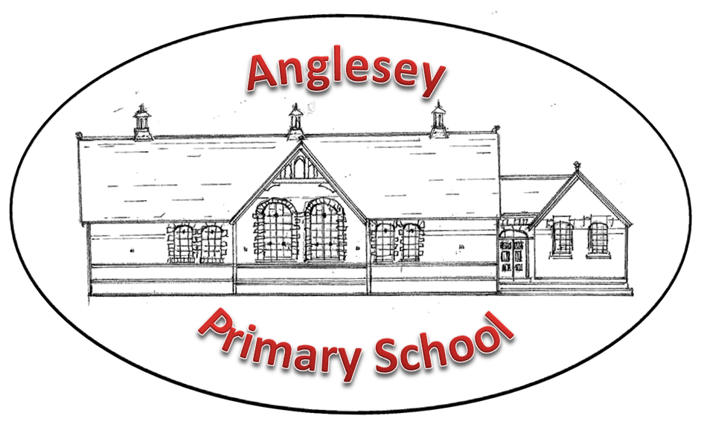

Dear Parents,

School will be closed on Monday to ALL PUPILS except the following groups:
- Children with an education Health Care Plan (we have identified these)
- Vulnerable children (we have identified these)
- Children of key workers
Key workers include:
- Health and Social care (doctors, midwives, paramedics, social workers and other frontline workers)
- Education and childcare
- Local and National Government
- Food and other necessary goods (food production, distribution, sale and delivery)
- Public safety and National Security (police, prison staff)
- Essential public transport (bus drivers)
For children of key workers, these children should be at home if possible. This is to prevent spread of infection as much as possible. YOU SHOULD NOT BRING CHILDREN INTO SCHOOL IF YOU OR ANY MEMBER OF YOUR HOUSEHOLD IS SELF-ISOLATING.

For any parents who fall into this category and have no other safe option for childcare, please report to the Reception area of the Infant Building from 9am. You will be required to provide some form of identification (ID badge, wage slip, business invoice, tax return) to verify your role. We would like to keep the numbers of children in school as low as possible to help contain further spread of COVID-19.

Thank you for your continued support.

Mr P Doddridge

Head Teacher

